ADB Commands

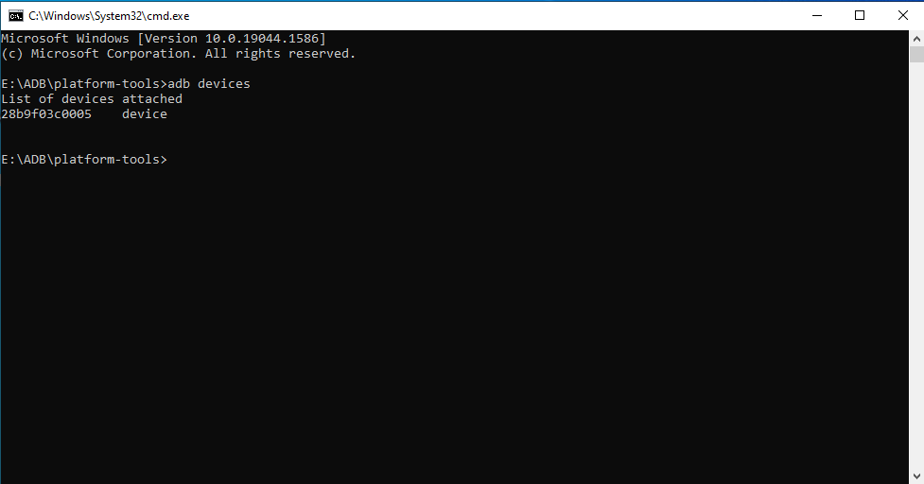

**Fig 1: adb devices**

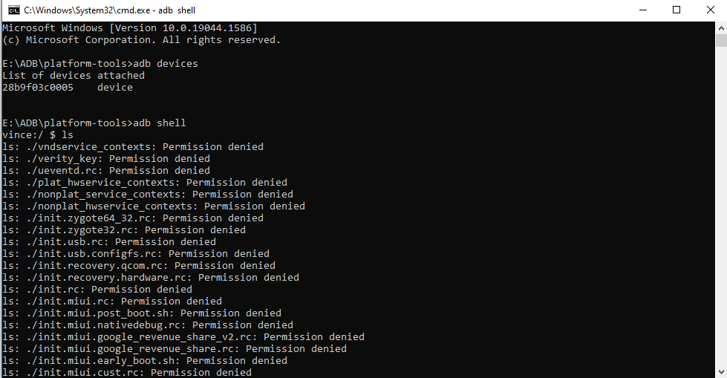

**Fig 2: adb shell**

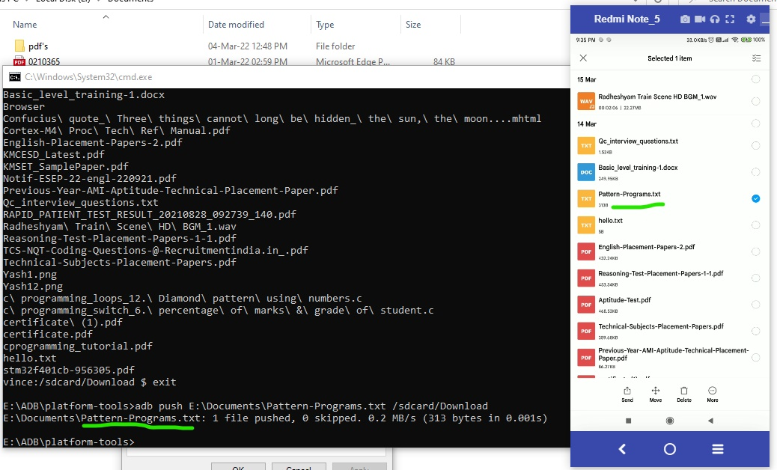

**Fig 3: adb push**

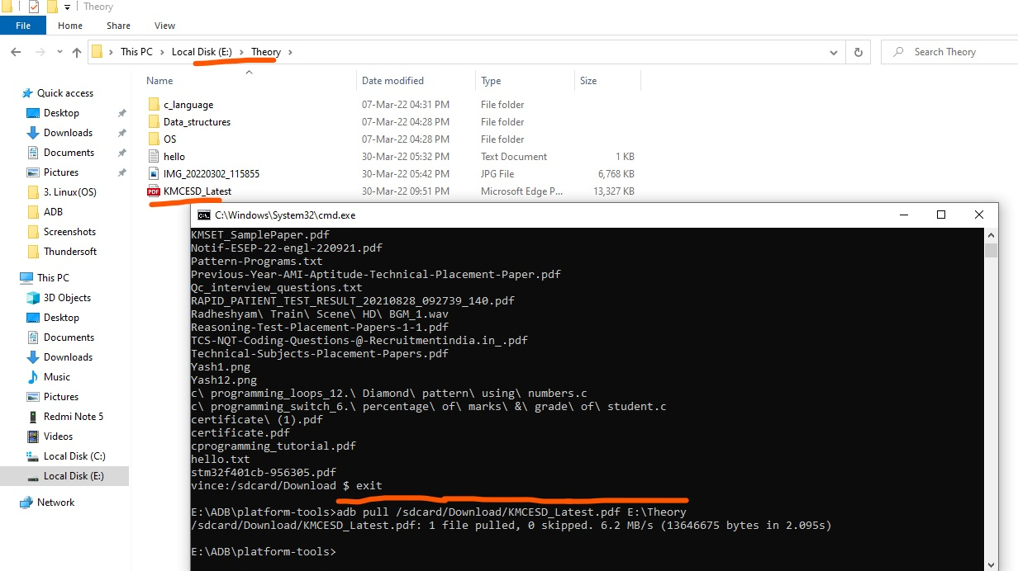

**Fig 4: adb pull**

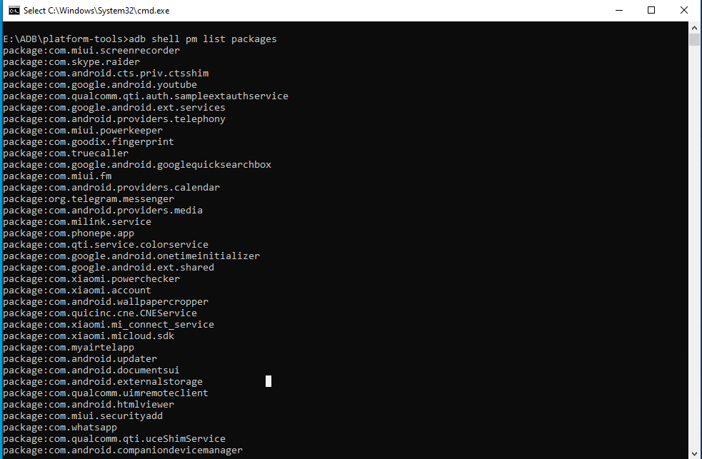

**Fig 5: adb shell pm list packages**

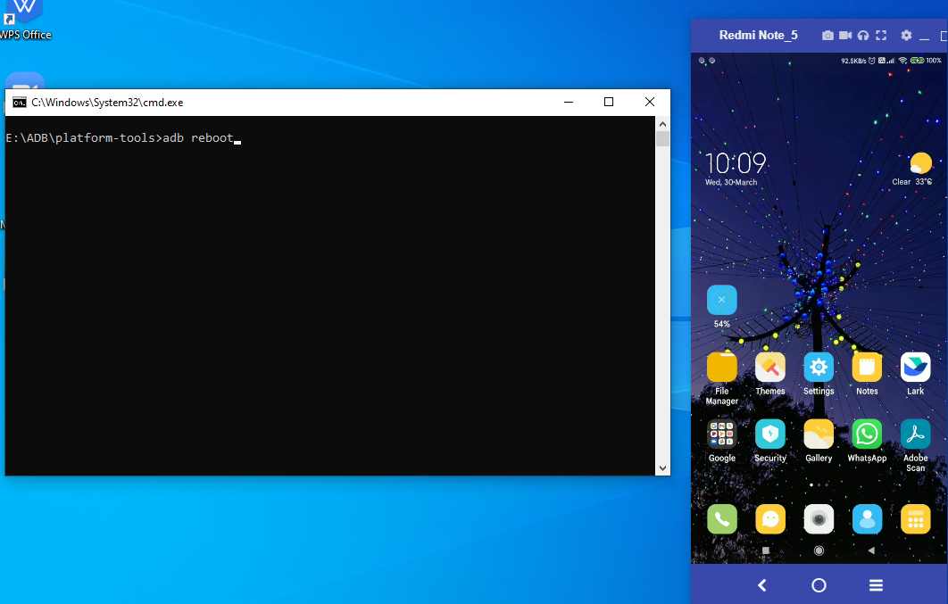

**Fig 6 a. adb reboot**

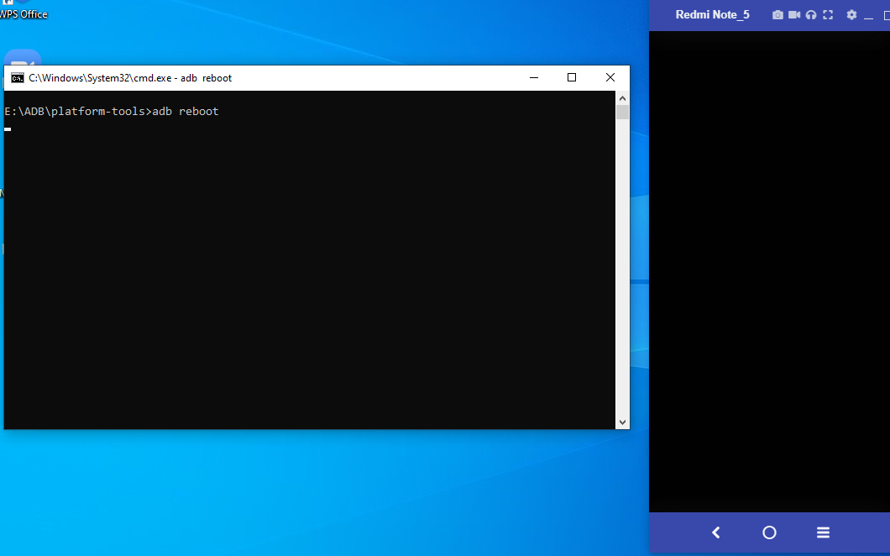

**Fig 6 b. adb reboot**

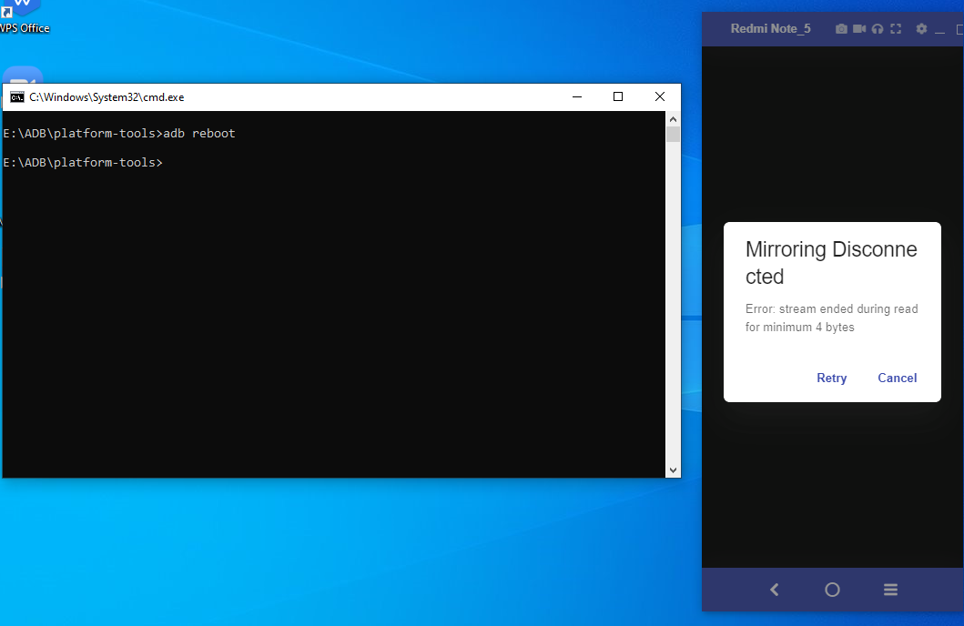

**Fig 6 c. adb reboot**

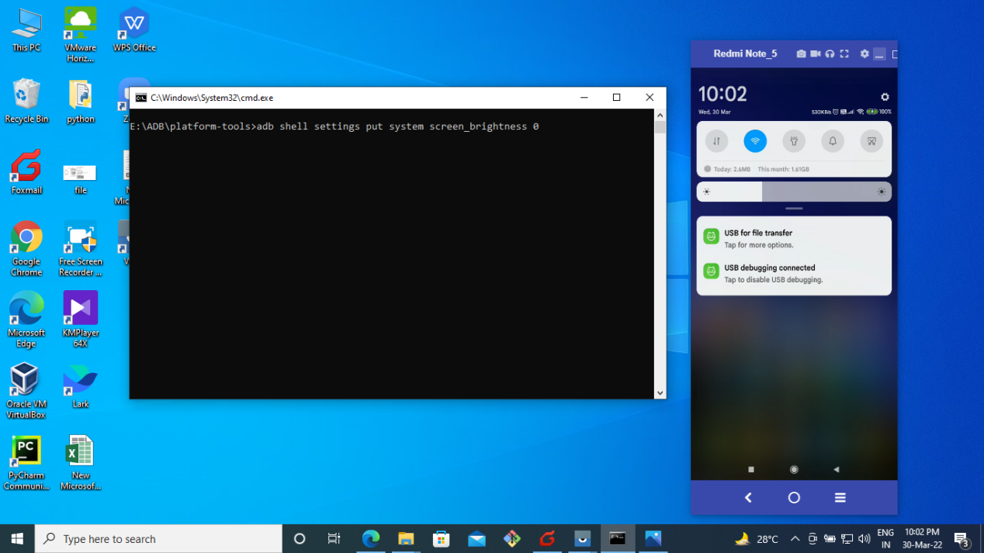

**Fig 7 a: Brightness before executing 0**

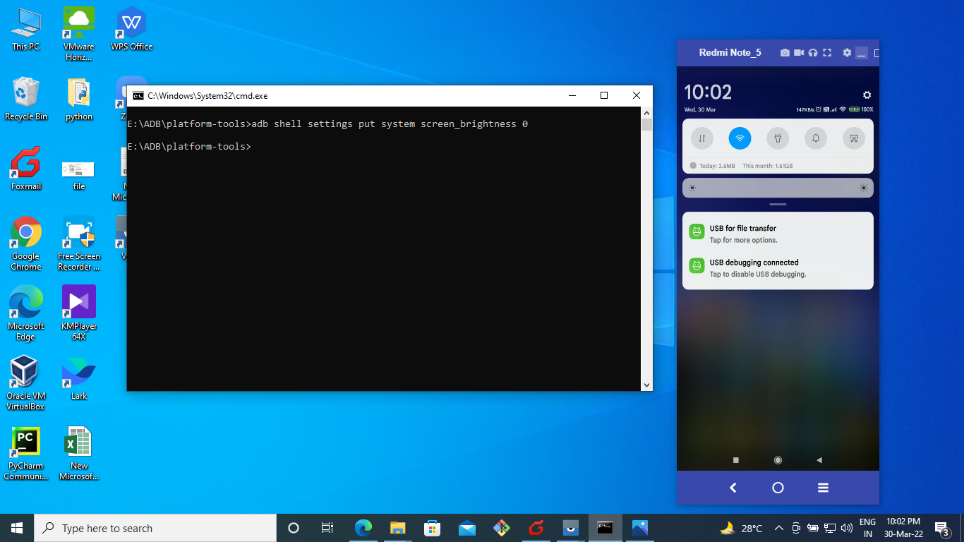

**Fig 7 b: Brightness after executing 0**

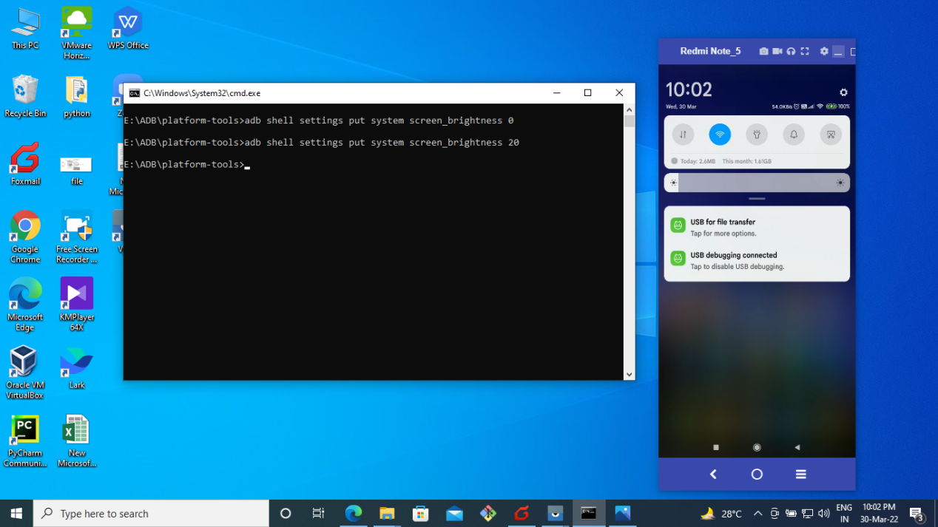

**Fig 7 c. Brightness after executing 20**

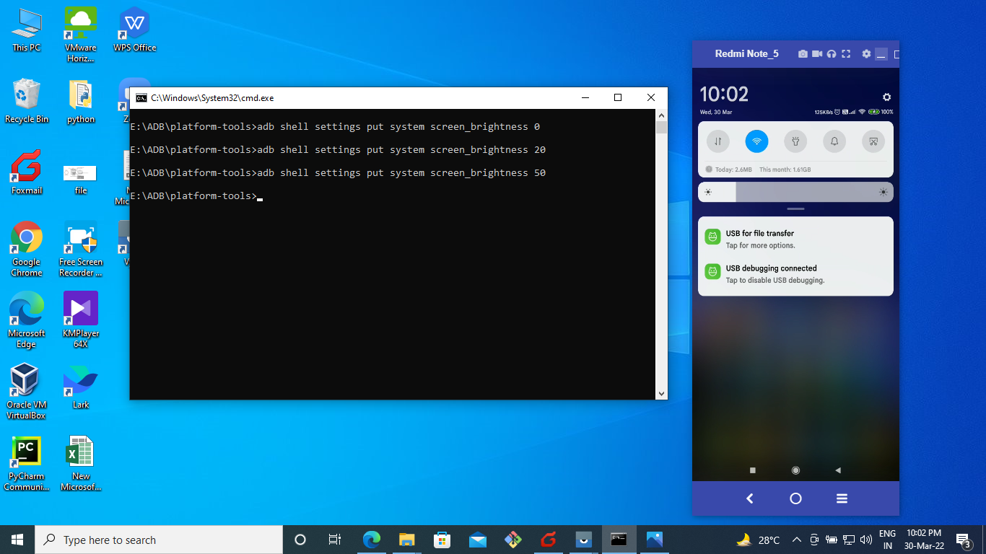

**Fig 7 d. Brightness after executing 50**

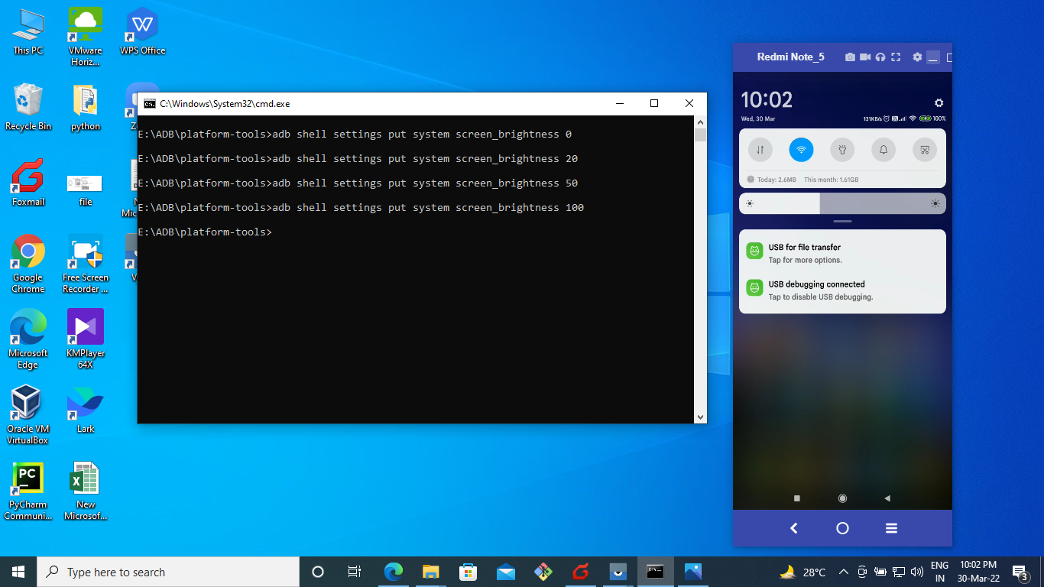

**Fig 7 d. Brightness after executing 100**